Code analysis: Before optimization. The isPrime function is taking forever.

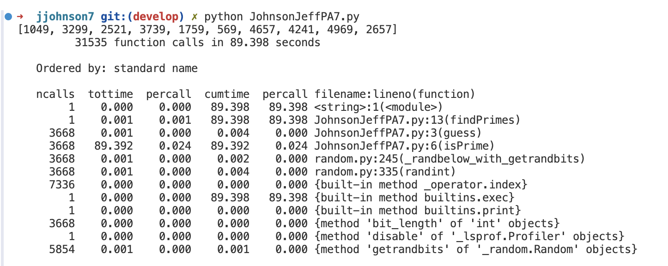
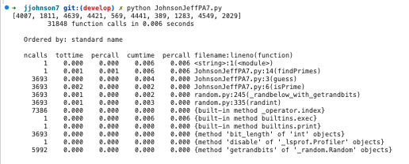
Old code:
def isPrime(x):
for i in range(x):
for j in range(x):
if i * j == x:
return False
return True

Code optimization:
def isPrime(x):
if x < 2:
return False
for i in range(2, int(x ** 0.5) + 1):
if x % i == 0:
return False
return True

Analysis and optimization report:
The original isPrime function was slow because it checked every possible pair of numbers to see if its product was equal to x. That means it had to do O(xˆ2) checks. To make it faster, instead of checking every pair, we just check if x can be divided evenly by any number from 2 up to its square root. This works because if a number has a factor larger than its square root, it must also have a smaller one that we already checked. That cuts the work down to about O(sqrt(x)) checks, making it much faster.

